**Lab Exercise 3- Switches inside Power Automate**

**In this Lab**

In this lab, you will create a cloud flow using a Power Automate to work with conditions and switch functions.

* **Learning objectives-** Conditions and Switches
* **Duration** - 30 minutes
* **Scenario** - Send an email based on the conditions and switches on when a an item is created or modified in a SharePoint list.
* **Prerequisites** - Each student must have a dedicated custom SharePoint list named **Work Progress Tracker**. This list was already created during the basic flow lab.

**Task 1**

a. Create an automated cloud flow called **Conditions Demo** and the trigger would be **When an item is created or modified** (SharePoint list)

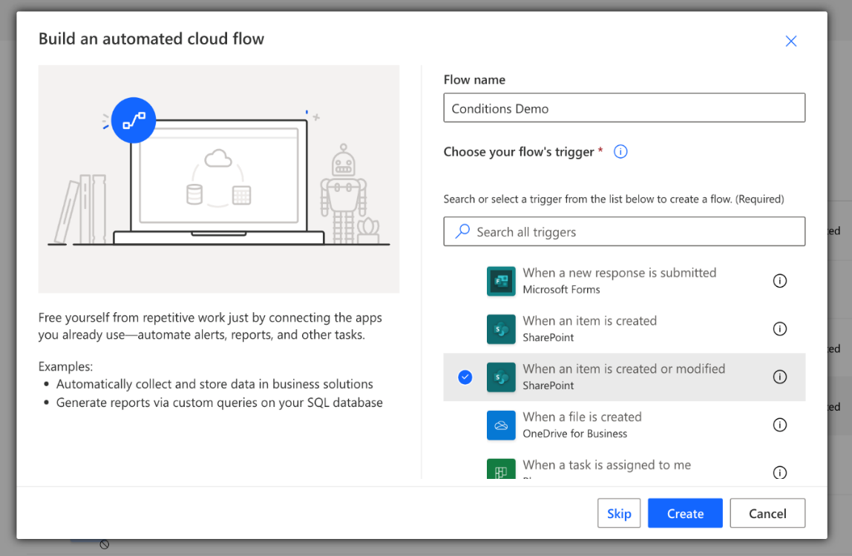

b. Configure the SharePoint trigger:

* Site Address: <SharePoint Site URL>
* List Name: Work progress tracker

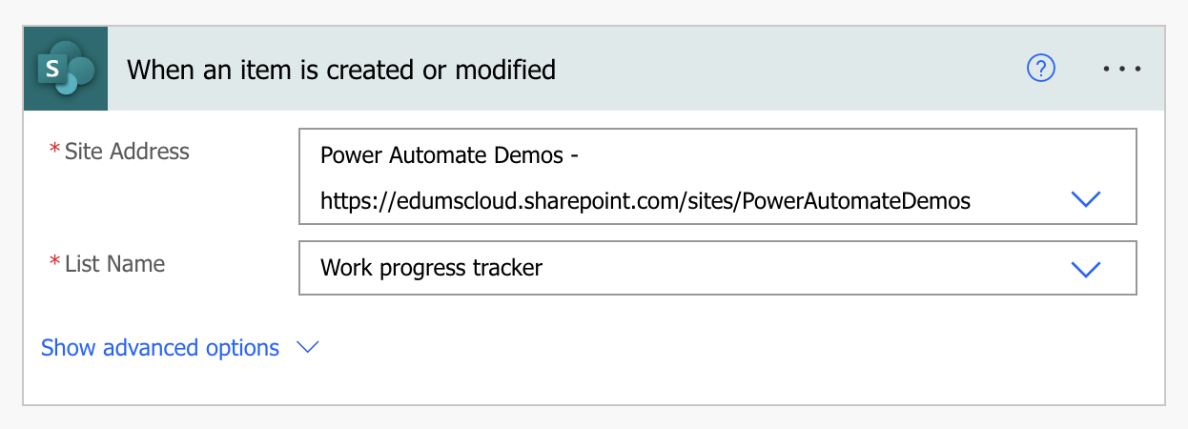

**Task 2**

a. Replace the **If** condition with a **Switch** statement of the **Priority Value**

* Case 1 equals **High** > Send email to yourself with subject **Case High**
* Case 2 equals **Medium** > Send email to yourself with subject **Case Medium**
* Case 3 equals **Low** > Send email to yourself with subject **Case Low**
* Case 4 equals **Critical** > Send email to yourself with subject **Case Critical**

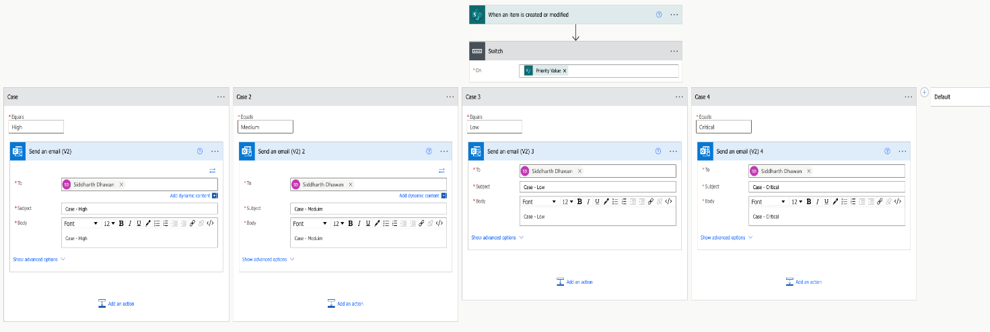

b. **Save** and Test the flow.

* Modify an item in the **Work Progress Tracker** SharePoint list.
* Verify the email based on relevant conditions.